

Embedded Systems

Sound to light

Joseph Morritt | Course Title | 2/25/20

Sign

Table of Contents

Abstract 2

Project plan 3

Project Plan map 4

Project Specification 6

Circuit plan 7

Preamp 7

Level shifter 8

Pre-Alpha Testing 1.0 9

Peak 9

Peak detector. 12

Circuit Plan Continued 14

+5V Supply. 16

+5V Regulator design 16

Schematic 18

Pre-Alpha Testing 1.2 19

Circuit operation 20

Pre-Alpha Testing 1.3 22

Testing the 5V supply 22

Testing ADC 22

Simulation Test 1.1 23

# Abstract

The creation of a sound to light converter also know as a digital VU meter. Is detailed with in the flowing log book it should. Counties the plaing , research testing

# Project plan

As The project is to create a sound to light circuit, so for the planning stage I will break the project down in to segments and identify what would need to be done within those areas.

Project overview

Electronic circuit

* Input stage circuit
  + Microphone
  + Pre-Amplification
  + Level shifter
  + Power amp
  + Peak detector
* Pic Microcontroller interfaces
  + ADC
* Output stage
  + DAC
  + LED Bar
  + Display driver
  + IO extender
* PCB
  + Schematic design
  + PCB placements
  + Components
  + Heat consideration

Software design

* Led activation
* Sound to light threshold, calibration.
* Interfaces setup

Date written 17/1/19

## Project Plan map

To plan out the project created a “draw.io” Project so I could map out the plane for the project’s designs. See appendix A for more info.

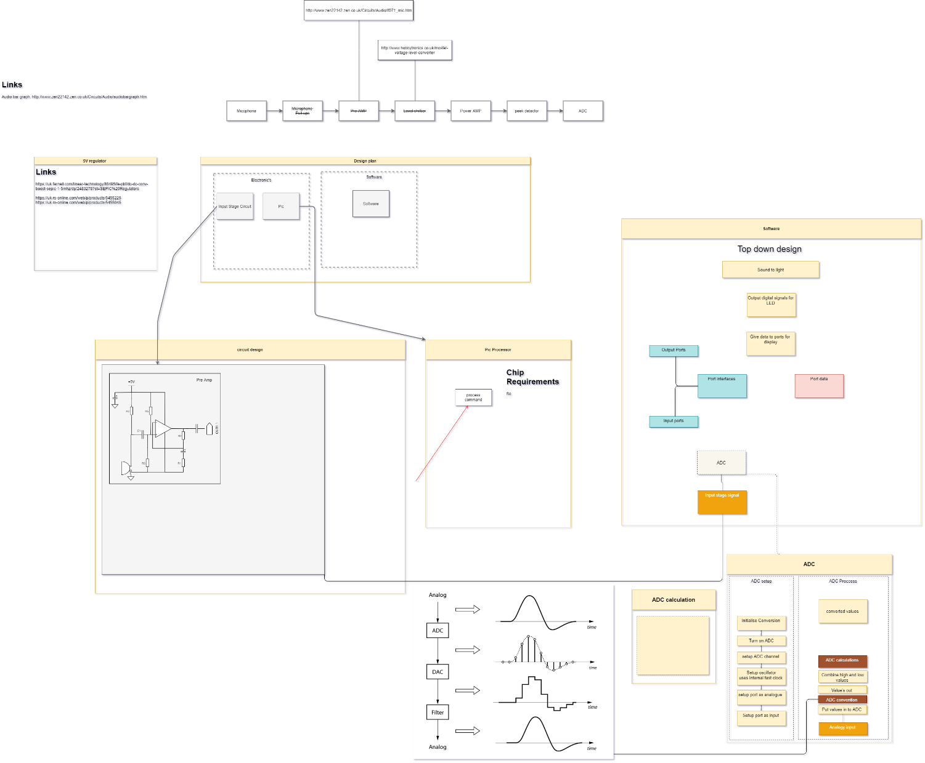

## Project Specification

**Overview**

The project is to create a sound to light converter

**Project Outline**

The function of the circuit is to take a sound input process this input signal so it can be input in to and ADC for processing. According to the measures value LED lights should be lit 10 LED to be used. So, alongside this a reset button and A dot and bar display option for the LED display

Advanced fetchers

Volume Control so the output scale can be adjusted. Addental display type should be added. Microcontroller sleep mode, non-voltien memory and analog out from DAC.

**Size**

The board should be around 100 x 100 mm and relatively low profile.

**Operating conditions**

I would use the commercial temperature range of 0 ° to 45 °C.

**Manufacturing**

The PCB should be

**Standard and specs**

Rosh

WEEE

**Testing**

Will carry out testing on all circuit sections, generate a circuit test speciation to verify functionality

## Circuit plan

### Preamp

So now that I have worked out the part project that need to be designed and completed, I started to do some research into the input stage circuit.

So, as the microphones output signal would be minimal, I deiced that I would preamplifier the signal, this would make it eases to work with and to reduces noises. So, I made a basic circuit diagram for the pre amp design. This would be valued up at the schematic stage.

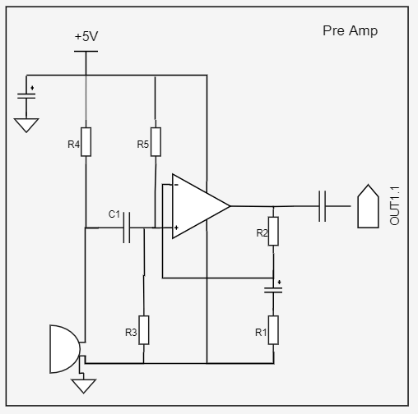

The design is a fairly standard non-inverting amp the gain is defined by Resistor’s R1 and R2. the capacitor c1 is a coupling capacitor to block any dc elements. R4 is used as a biasing resistor as the we would be using an ECM microphone and the current limit need to be set. *Date written 17/1/20*

### Level shifter

The next part of the input stage design is the level shifter this is to be implemented as the peak detector would not work with the negative side of the signals. To start the design of the level shifter I decided to do some research. But most of the reference material seamed to only be DC based design, to check the feasibility of the design, I would use LT spice to simulate it.

This is my Spice simulation circuit of the design.

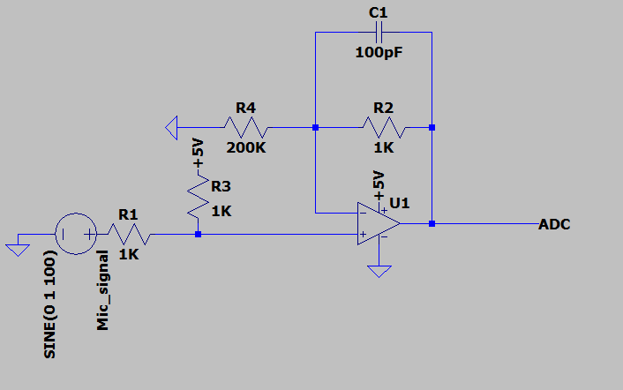

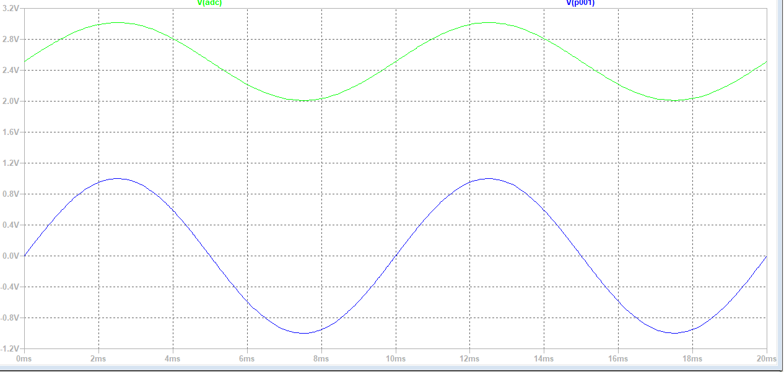The gain for the design is defined under with the equation simulation

The simulation of the level shifter is shown above the blue wave is the ac input from the mic. The green wave is the offset waveform.

Date written 18/1/20

## Pre-Alpha Testing 1.0

### Peak

So, as I had designed two section of the input stage I decide to perform some testing on what I made, this testing was done one the 23/1/20. What I discovered was that the microphone that was being proved already had and amplifier on board so the pre amp circuit that I had designed would not have to be implemented any more. So, the circuit plan would have to be amended slightly. The microphone Circuit is shown bellow

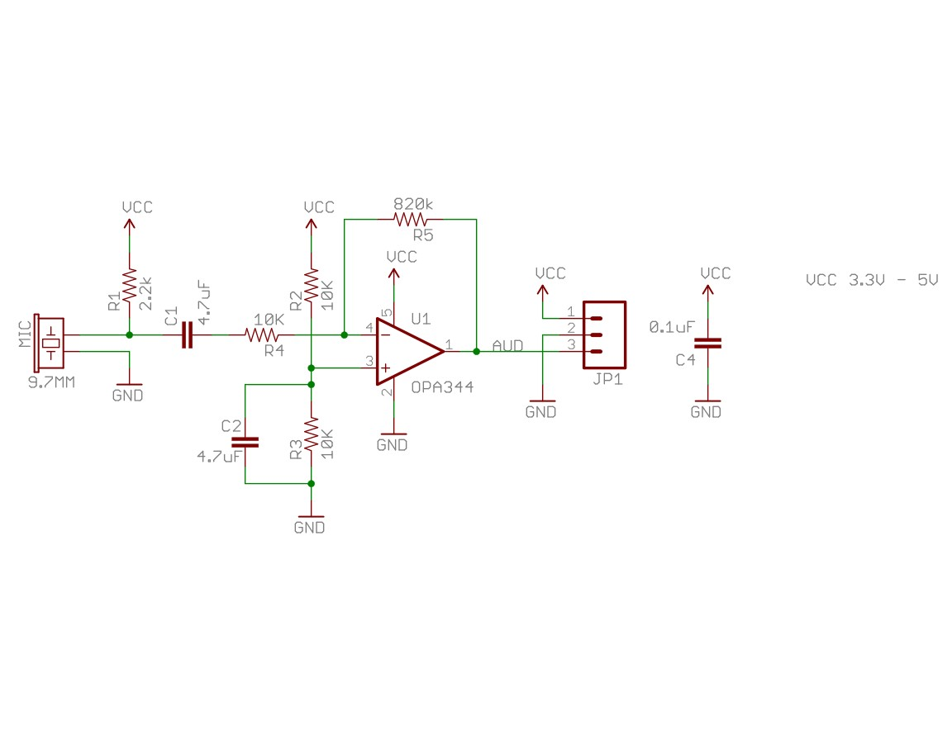

Figure Microphone Circuit

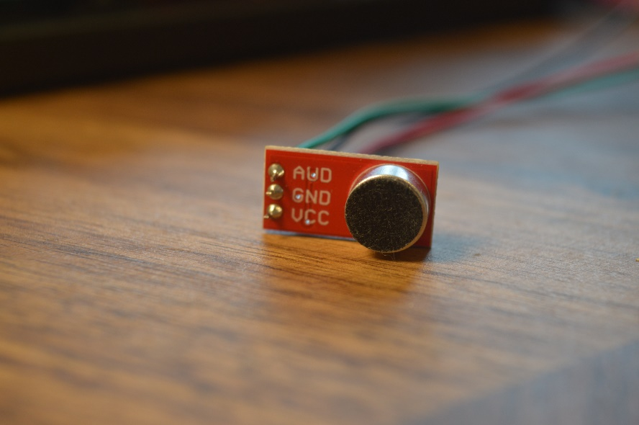

Figure Microphone module

The Microphone module was powered up with 5V Supply, this enabled the onboard logic of the models such as the op-amp which would amplify the signal. The output was connected to an oscilloscope using a scope probe. The setting for the scope was dc coupling with channel set to 2V/div with a time base of 500ms.

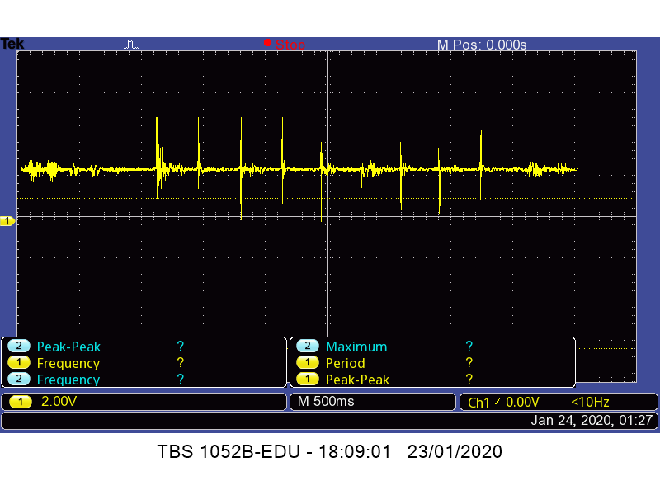

Figure Microphone output.

So, when analyzing this output, I discovered that there would not be a invert signal as a mistakenly thought when planning the circuits for the design. So, this would mean that I would not need to level shift up the design, but as I discover later that circuit would come to some use. The measurement also showed that output signals Vmax would peak at 5V and Vlow at 2.5V.

### Peak detector.

I Also decide to implement a basic peck detector to see how it interacted with the sound input.

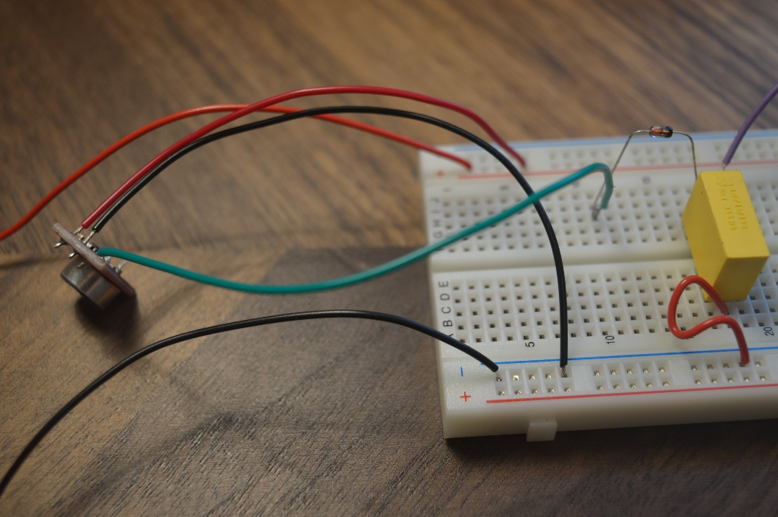

Figure Peak detector

The design is based on the one found in <https://www.academia.edu/37219236/Paul_Horowitz_Winfield_Hill_The_Art_of_Electronics_Cambridge_University_Press_2015_>

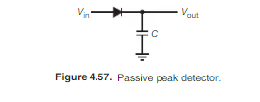

This is the peck detector output on the scope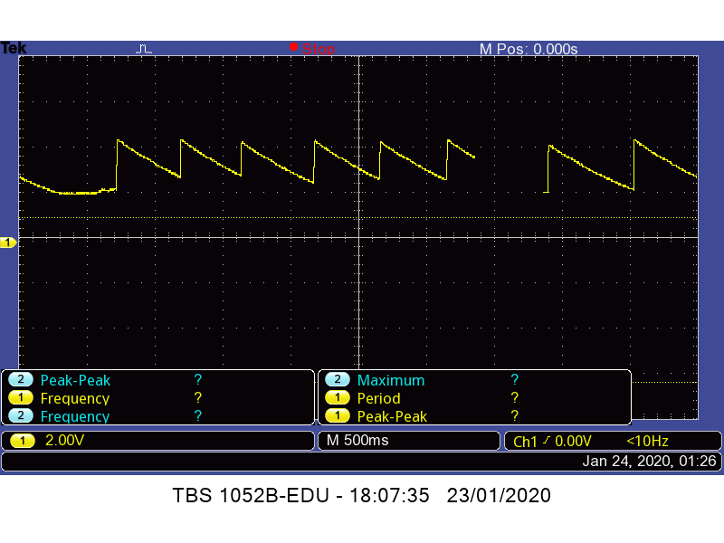

Date Written 25/1/20

## Circuit Plan Continued

Now I had knew exactly what my input signal would is likely to be. I consider how the rest of the output stage would be designed.

As the microphone signal would have to go into and ADC, at the end stage. Due to the Fact the Most Pic ADC max voltage input is 5V this would mean that most of the Restion would already be lost as the 0 to 2.5 v Range would not be used.

To Resolve this the signal would have to be level shifted down. I would modify my circuit to drop the Vlow down to V0.

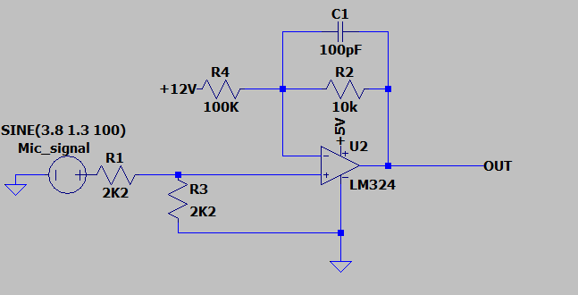

Figure Level shifter

This is this the modified circuit of the level shifter. The Circuit was then simulated the resulting waveform are shown in Figure 6

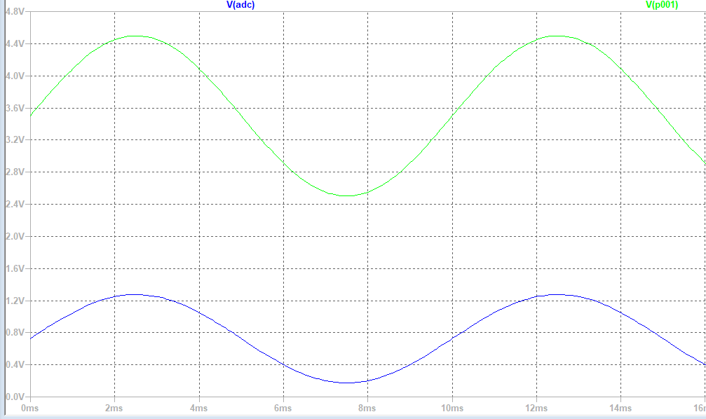

Figure Level shift output

The values used it this design would be modified for uses in application such as the R1 one input resistor as this should be impedances matched agented the input. So R2 will be inversely scaled against this value.

Now the signal has the same affect when the maximum voltage is being applied but in the lower half as it can only scale from 0 to 1.2. So, to rectify this issue, the signal will be amplified so that it covers a larger range.

The circuit is designed and is shown bellow in

Figure 7

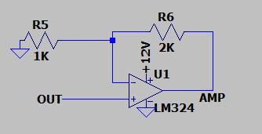Figure Signal amp

Date written 1/2/20

## +5V Supply.

As I knew the I would need a 5V supply leveling me some extra time to implement it I, though I might Try and develop a Switch mode power supply using a DC/DC convert. As I thought it be a good learning point and a step in to power electronics. As switch mode are much more efficient then liner regulators.   
If I was unable to finish it development, of the switch mode supply. I could quite easily switch in a Liner regulator if need.

I statured of by doing some research in to their operation, useful for later when I would properly have to fault find it. Also allowing me to explore my options.

The research allowed me to create a specification for the regulator.

* Take a 12V input
* 5V Output
* Minimal Voltage ripple
* Invert capability (This was spec when -5 V was required)
* High Efficiency
* Capable of being simulated in LTspice
* Low Queasiest current
* Internal clock
* SMD IC package with legs

This meant I would be looking for a buck or Septic convert to help with this I used analog devices Regulator search tool [Ref 1]. The search too allowed me to filter down the results helping me ratify my choice of deices I decided on the LT8362 , this was selected as it fit into my specification and was suggested for uses in new designs .

### +5V Regulator design

Now the convert has been selected, the power supply external circuit is to be designed. This involves component values for the regulator design this is done by calculation reference to design notes and simulation.

Figure 8 DC/DC pinout

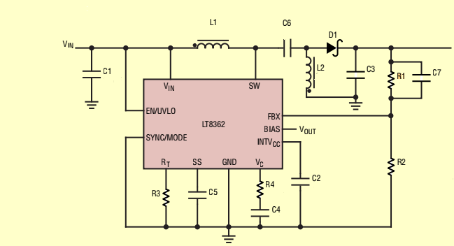

Figure 9 DC/DC Pinout

This is the layout of the SEPIC converter

To start the design the duty cycle of the convert should be calculated.

Written on 8/2/20

[Ref 1]

www.analog.com. (n.d.). Switching Regulators | Analog Devices. [online] Available at: https://www.analog.com/en/products/power-management/switching-regulators.html [Accessed 22 Feb. 2020].

## Schematic

So Started some work on schematic

## Pre-Alpha Testing 1.2

So, I discovered that I did not do my previous designed test with a coupling capacitor on the microphone input. This now means that the out of the microphone maxes out goes between 2.5 and -2.5. as the DC offset has been removed.

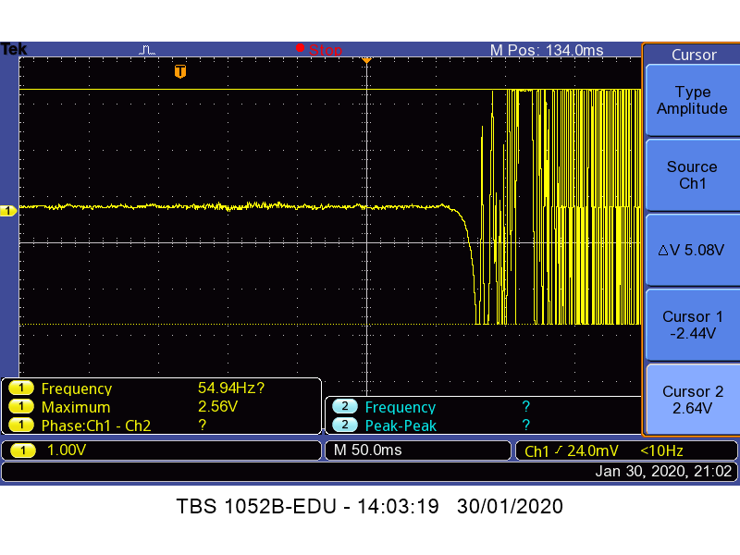

This means that I how to reconsider how I am going to setup the input stage circuit as the design would now.

So, I reconsider what I would need to do so reconsidering what need to be designs. So, what I had not consider before was the peak detector would only work on the positive peaks even if they were level shifted up. So, the input stage would only need to be a Peak detector and amp for volume control.

So, a peak detector circuit was tested with the altered microphone output

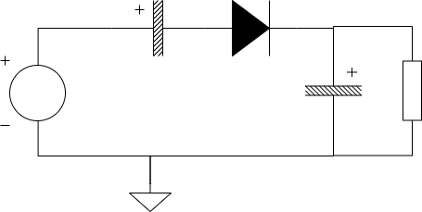

### Circuit operation

So, the diode cuts off the negative cycle of the signal the parallel capacitor holds the peak value the Resistor will cause the capacitor to discharge. Together they form an RC circuit so the time period is defined off those values.

It took me a while to work out the value to get the right peak detector but I managed to get an operational one

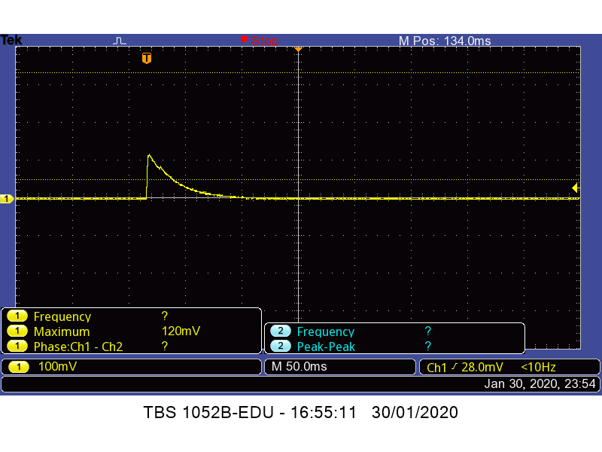

Figure Circuit test

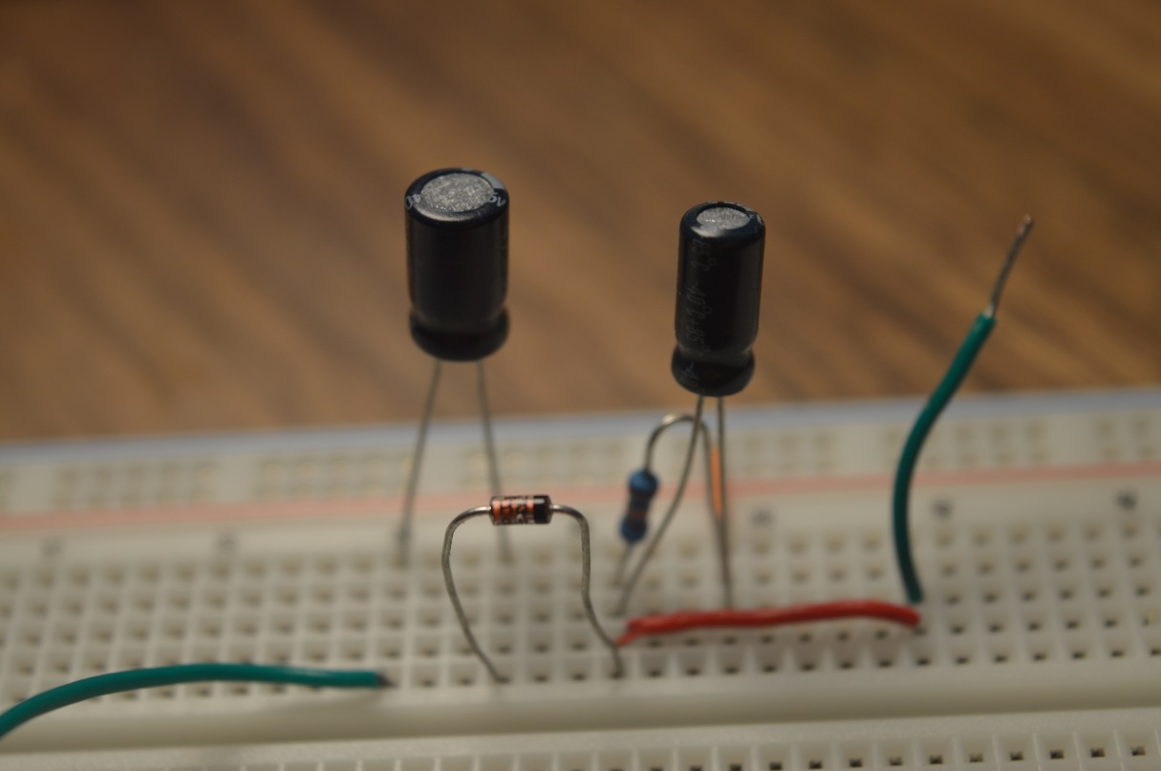

Figure Peak Detector Circuit

Figure 9 shows the Peak detector circuit construction with a coupling capacitor on the input.

As the peak signal out Is small, I would have amplified the signal for easy processing.

Written on 14/2/20

## Pre-Alpha Testing 1.3

### Testing the 5V supply

### Testing ADC

## Simulation Test 1.1